Syllamonstres : Cartes de syllabes 3 (à découper et plastifier)

  BONUS | bonus | BONUS | bonus
BONUS | bonus | BONUS | bonus
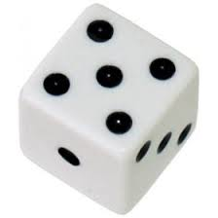  BONUS | bonus | BONUS | bonus
BONUS | bonus | BONUS | bonus
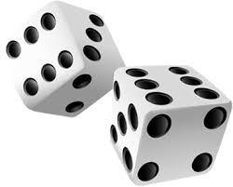  BONUS | bonus | BONUS | bonus

